**PERU SIGNS – LEARNING RATE 5E-4**

MODEL 0

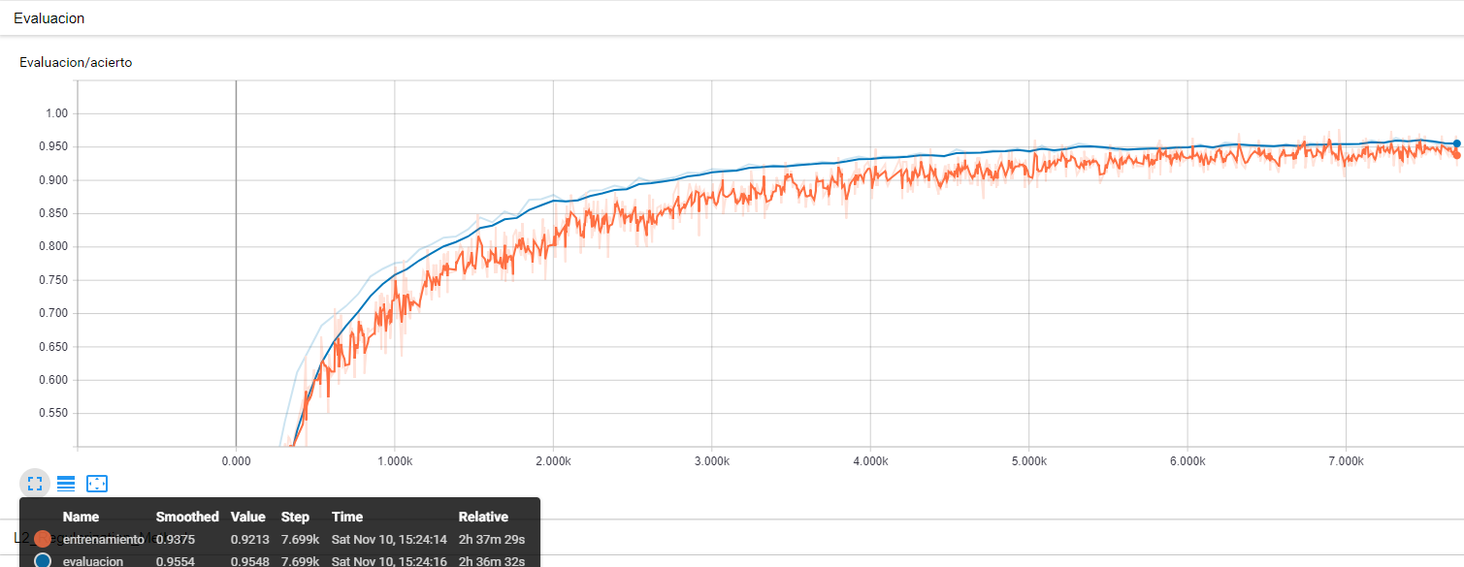

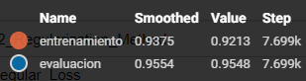

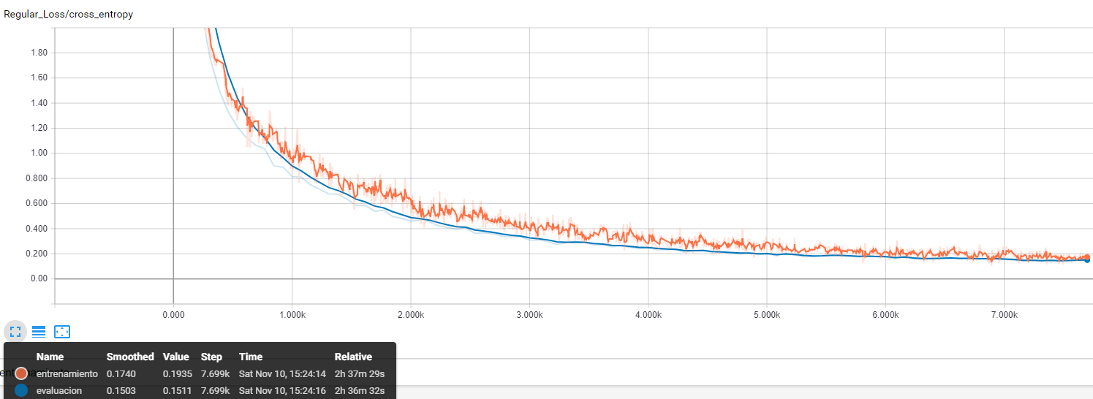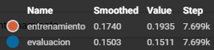

MODEL 1

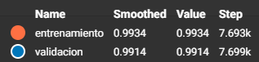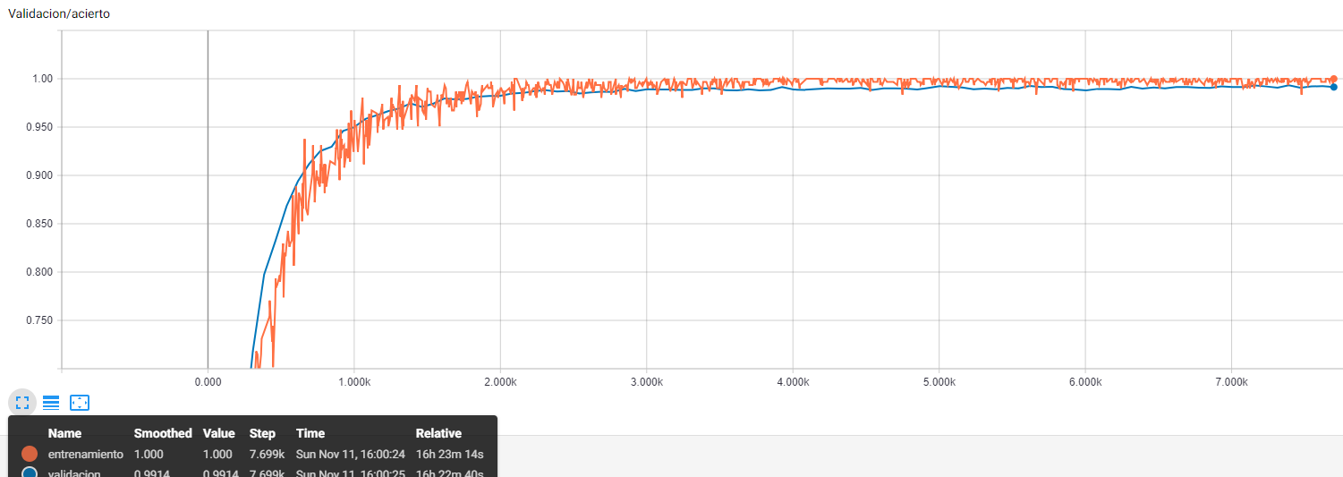

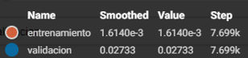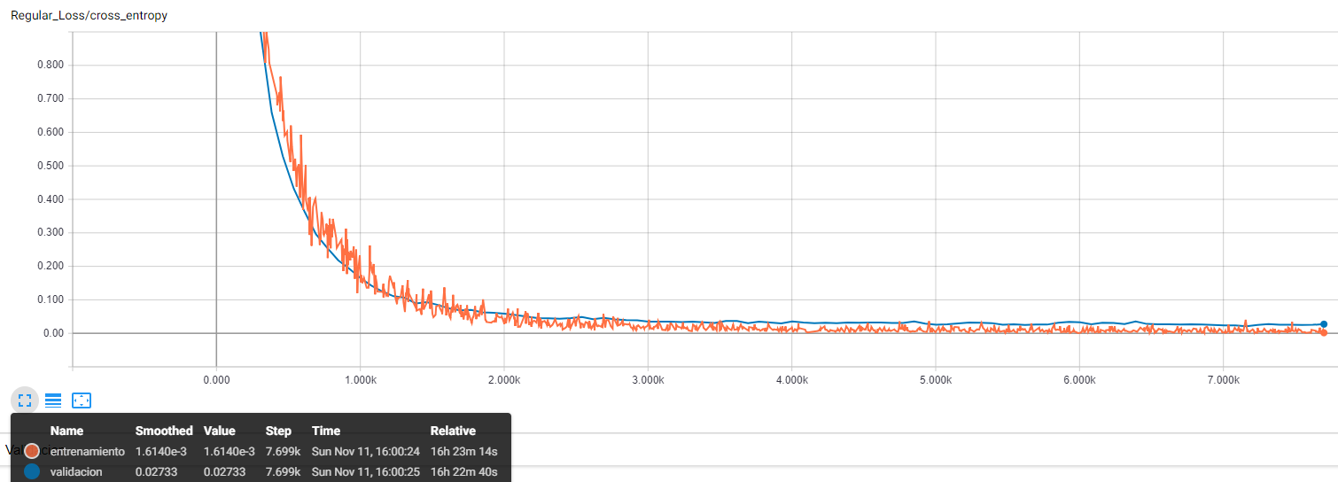

MODEL 4

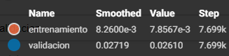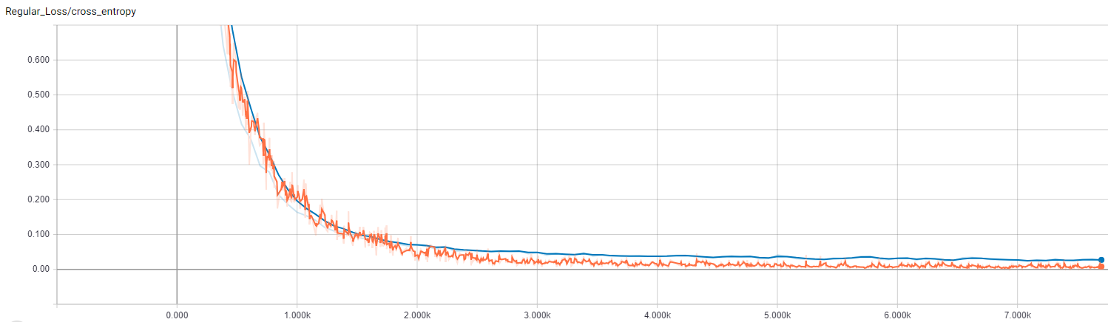

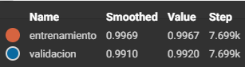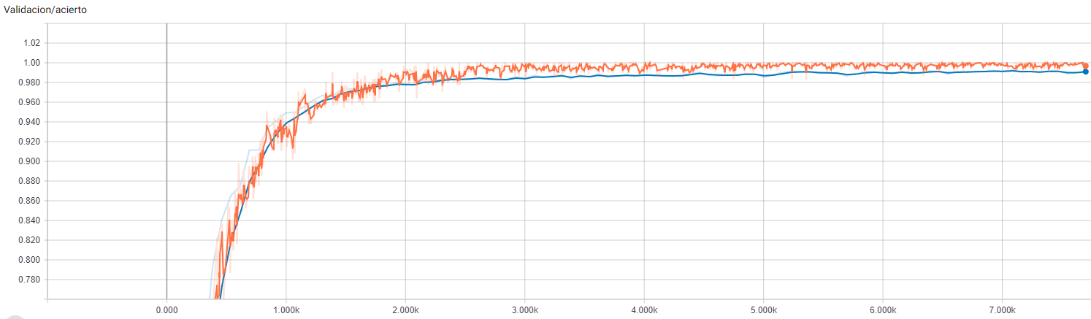

MODELO 6

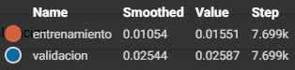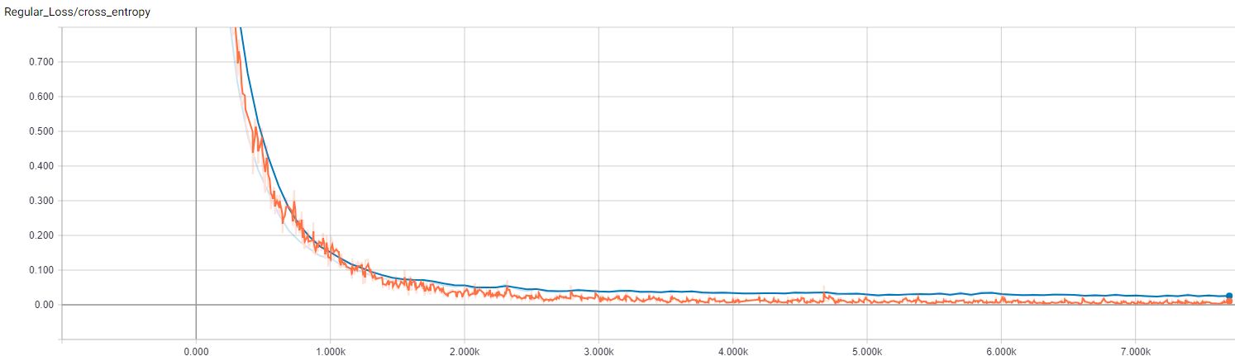

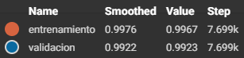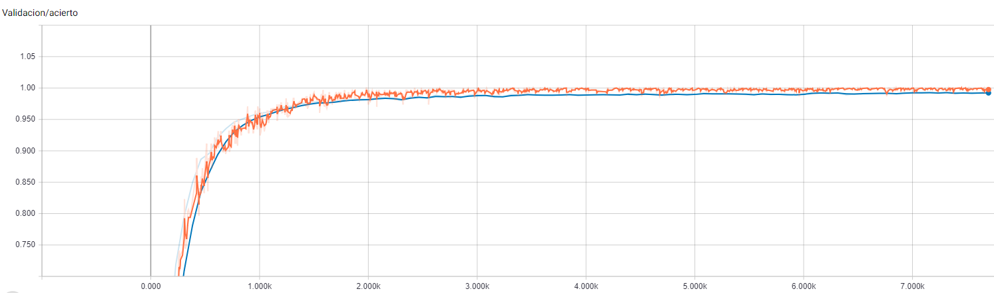

MODELO 7

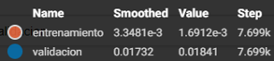 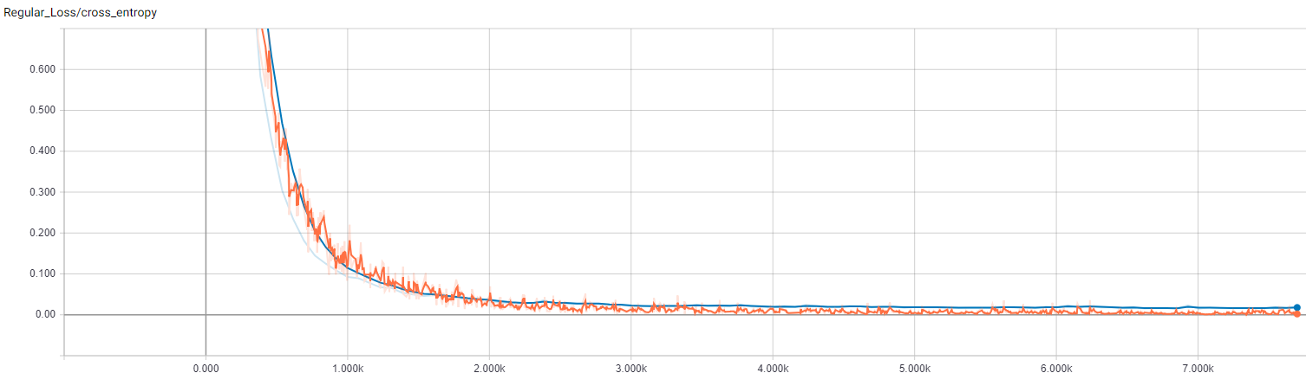

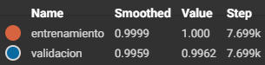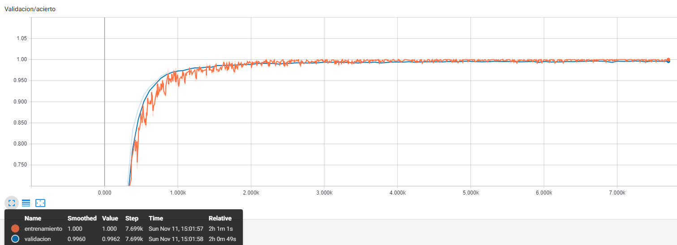

**GERMAN SIGNS – LEARNING RATE 5E-4**

MODEL 0

Saved directly in folder

MODEL 1

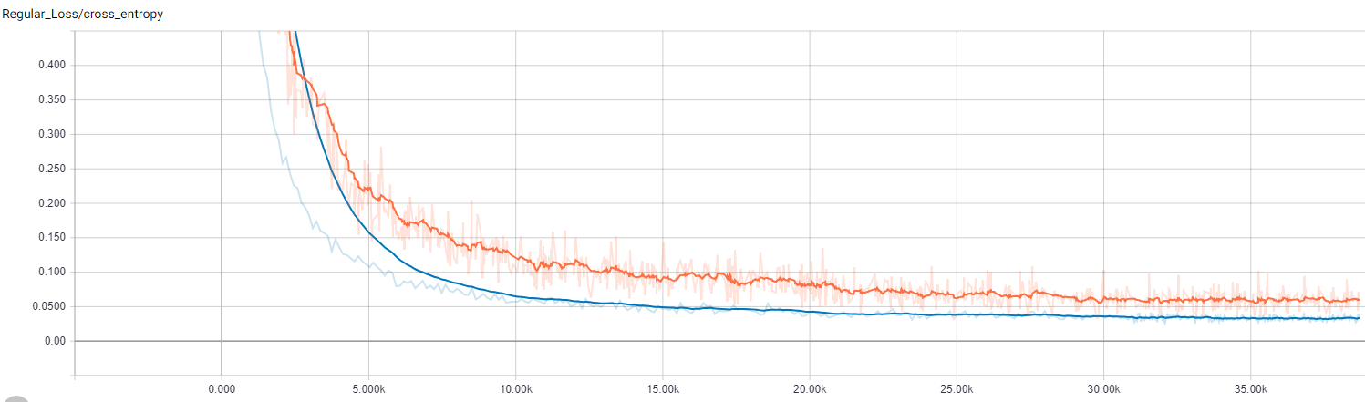

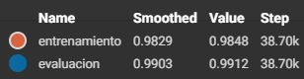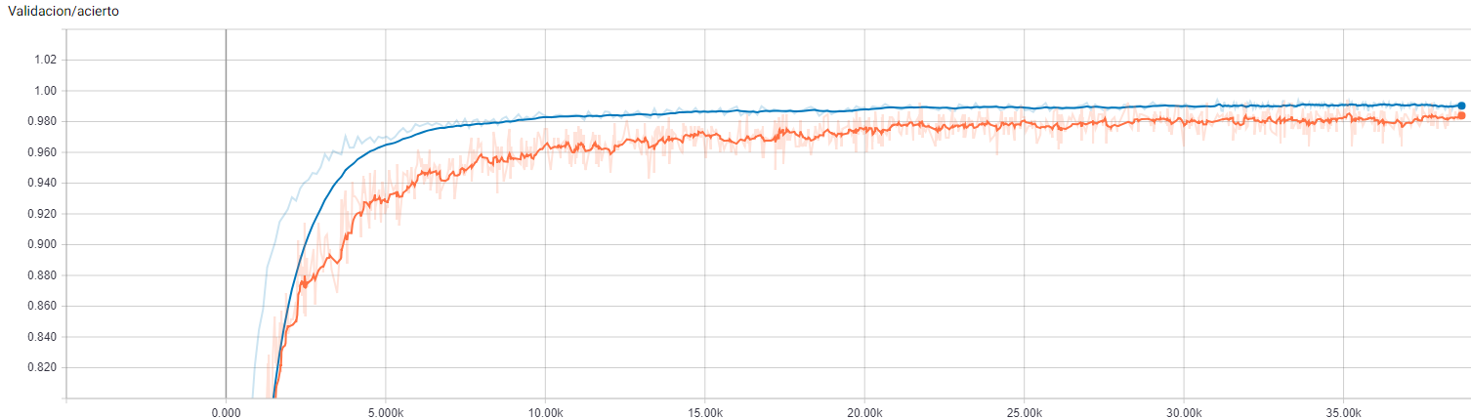

MODEL 4

MODEL 6

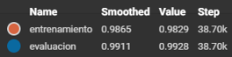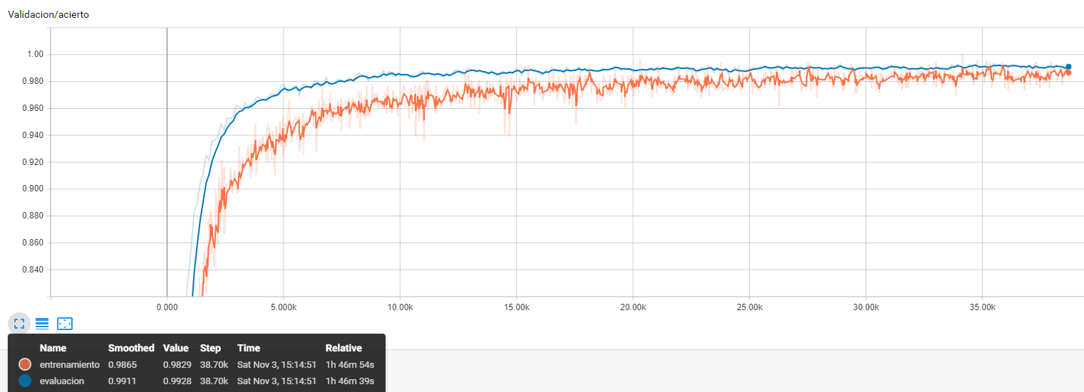

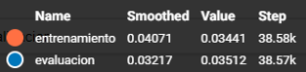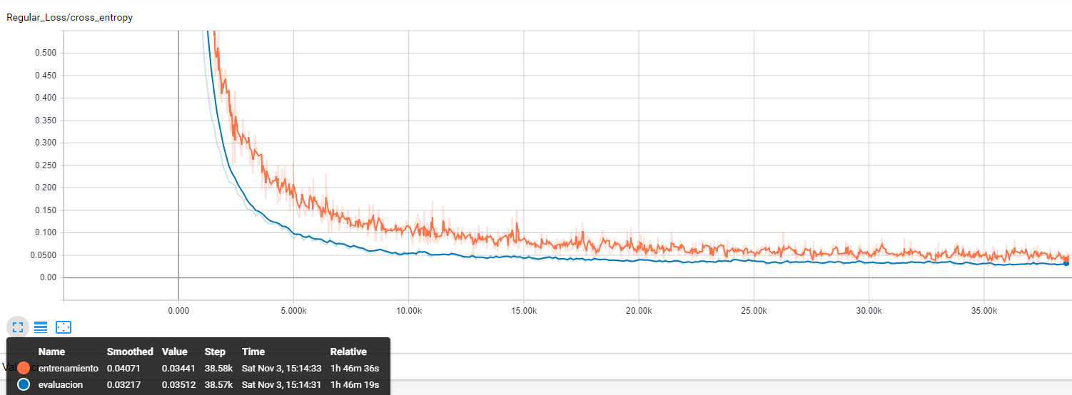

MODEL 7

